Autumn DROP-IN SESSIONS for Early Years settings in DSPL’s 6 and 9 with Emotional Wellbeing and Behaviour Specialist Dominique Johnson:
Book time with Dominique Johnson: Wednesday 17th September 2025 EWB Drop in
Book time with Dominique Johnson: Tuesday 30th September 2025 EWB Drop in

Book time with Dominique Johnson: Monday 13th October 2025 EWB Drop in
Book time with Dominique Johnson: Thursday 30th October 2025 EWB Drop in (HALF TERM)
Book time with Dominique Johnson: Tuesday 11th November 2025 EWB Drop in

Book time with Dominique Johnson: Monday 24th November 2025 EWB Drop in

Book time with Dominique Johnson: Wednesday 10th December 2025 EWB Drop in

If you would like advice around planning for Emotional Wellbeing and Behaviour in the Early Years, please click the preferred date to book a 30-minute MS Teams time slot. Once in the booking system, please access the calendar and click on the relevant date which will then give you available time slots.
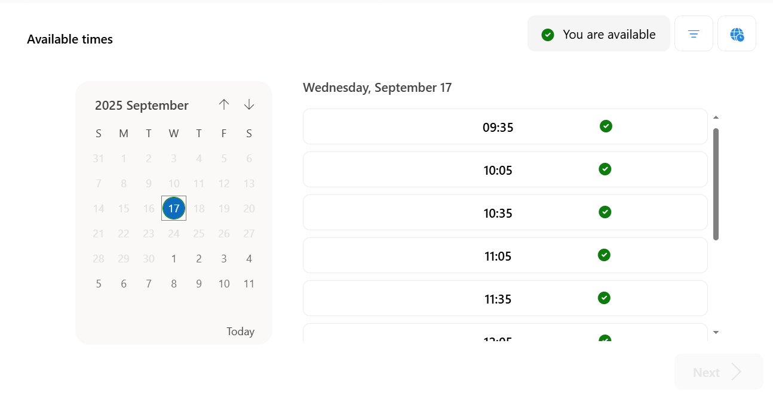
At time of booking please send a signed consent single service request to WAT3RIV.ISLTEAM@hertfordshire.gov.uk

